For immediate release

IEDR Annual Report shows company turnover increased 5% in 2015

New dot ie domain registrations in 2015 increased by 13% to reach their highest level since 2011;

Net increase in registrations of 12,929, 48% up from 2014;

Spend on promotion, sponsorship and advertising increases significantly as national registry drives home online message to SMEs.

The dot ie Domain Registry (IEDR) has announced its financial and registration results for the year ending 31 December 2015.

There were 35,225 new dot ie registrations in 2015, an increase of 13.4% when compared to 2014 (31,072). Accounting for dot ie non-renewals or deletions, there was a net increase in registrations of 12,929, an increase of 48% on 2014 net registrations.

Accordingly, turnover at the company increased 5% to €2.86 million. The company registered an operating loss of €517,082 in 2015. The loss is principally accounted for as a result of expenditure of €508,000 on activities under the company’s Strategic Development Fund.

The Fund, which has now been extended into 2016, was established to finance promotion, marketing and customer service initiatives for the dot ie namespace. In 2015, the Fund supported activities such as website development and e-commerce assistance for SMEs via the OPTIMISE Fund, marketing and advertising campaigns for .ie accredited registrars and local and national integrated media promotional campaigns.

The IEDR also continued to work with key stakeholder and SME representative groups to support the Irish Internet community via event sponsorships and partnerships.

The positive growth in dot ie domain registrations reflects improvements in the wider Irish economy, particularly increased use of websites by growing numbers of online businesses matched by a return of consumer confidence and improved levels of disposal income, driving online shopping.

Overall, the company’s financial position remains strong with Members Funds at end 2015 standing at €3.7 million and €5.75 million in liquid funds and investments. While IEDR’s financial investments had a market value of €3.1 million at 31 December 2015.

Operational highlights of 2015

A number of policy changes were implemented to expand the dot ie domain landscape in 2015, including allowing for the availability of, for the first time, one and two letter dot ie domain names. Internationalised Domain Names (IDNs) which allow people to use domain names in their native language were also approved meaning that domains with fadas will be available to purchase and use in 2016.

The dot ie domain registry also recorded another first in Q1, 2015 when it reached the milestone of 200,000 registered dot ie domains, with Basecamp Adventure Park in Limerick identified as Ireland’s 200,000th dot ie domain name.

2015 saw the publication of IEDR’s bi-annual flagship research ‘The dot ie Digital Health Index’ which examines the health of 500 Irish SMEs’ digital presence by analysing the number of digital assets (websites, apps, social media accounts and online sales ability) used by SMEs, and the perceived quality of these assets. 1,500 SMEs were surveyed over three waves of research.

IEDR’s OPTIMISE Fund supports SMEs by working shoulder-to-shoulder with them to provide their business with e-commerce upgrades and boost their online presence. The Fund marked its 5th anniversary in 2015 and has supported 75 SMEs to date, with a further 15 businesses participating in the Fund in 2016.

Outlook for 2016

The outlook for 2016 remains encouraging, however growth will be influenced by the macro-economic environment with all sectors of Irish business likely to be impacted by global issues such as Brexit. In the domain name industry significant international developments may arise as the US government continues to step back from its formal role in Internet governance. The ongoing expansion of the global domain namespace with the launch of new gTLDs in 2016 will continue to represent a challenge for brand managers, trademark and patent holders and IP rights owners.

In addition, to one and two letter and Irish language, or fada-enabled domains, IEDR will launch a new service later in 2016, which allows existing domain holders to sell-on their ‘right to use’ dot ie domains. Buyers will need to comply with the current rules for new applicants.

David Curtin, Chief Executive of IEDR, said: “2015 overall was a positive year for IEDR, one in which we consolidated our market leader status and positioned the company for long-term growth and sustainability. In 2015 and again in 2016, we are investing in the future of the dot ie domain name.

“We continue to remain the identifiably Irish domain of choice for Irish businesses and are working closely with the SME community to ensure that all within it appreciate the value of having an online and digital presence. The number of businesses with a website and online presence continues to grow each year. Notwithstanding this, policymakers must continue to strive to drive home the message that e-commerce functionality is a key component for all Irish businesses, just as important as any other aspect of running a business,” added Curtin.

The IEDR is the official registry for dot ie internet domain names and maintains the database of registered dot ie domain names.

//ENDS

For more information, contact:

Amanda Glancy, PR360: amanda@pr360.ie; 087 227 3108
Nuala Ryan, PR360: nuala@pr360.ie; 083 421 2733

Notes to editor:

Link to IEDR Annual Report and Review 2015:

https://www.iedr.ie/wp-content/uploads/2014/04/IEDR-Annual-Report-Review-2015.pdf

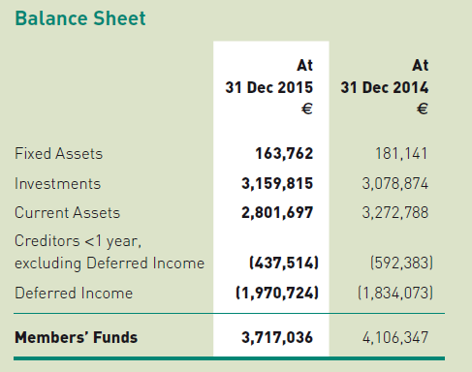
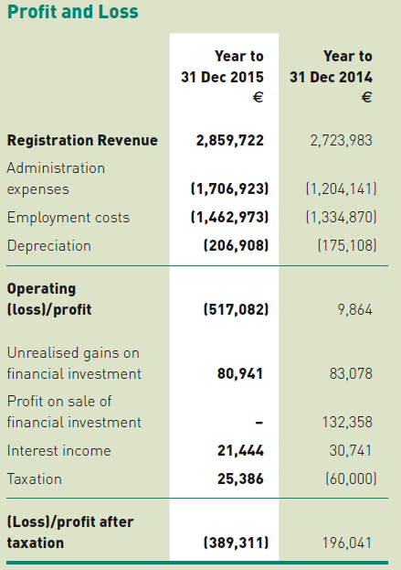

About IEDR

The IE Domain Registry (IEDR) is responsible for the management and administration of Ireland’s official Internet address dot ie, in the interest of the Irish and global Internet communities. The IEDR operates the domain name system (DNS) for the dot ie namespace, facilitates a dispute resolution service and operates a public ‘Whois’ lookup service for dot ie domains.

The IEDR is a managed registry which means that there are policies and procedures governing the registration of dot ie domain names. New applications are reviewed to ensure compliance with the terms and conditions of registration.

