16 August 2018
IE Domain Registry reaches key milestone as 250,000th .ie domain registered
- Dublin-based beauty salon, The Wicklow Street Clinic, identified as 250,000th registered .ie domain, www.thewicklowstreetclinic.ie
- IE Domain Registry records best ever half-year period as 154 new .ie domains registered every day between January and the end of June 2018; thirty-one of thirty-two counties in Ireland recorded increases compared to H1 2017
- New ‘liberalisation’ policy has made it easier and faster to register a .ie domain
- According to 2017 Annual Report, IE Domain Registry recorded a 3 percent increase in turnover from €3.03 million in 2016 to €3.12 million in 2017
- David Curtin, IE Domain Registry CEO: “Customers value ease and convenience and in order to survive, SMEs need to respond to competition from international websites.”

There are now over a quarter of a million registered .ie domains, according to IE Domain Registry, the company that manages and maintains Ireland’s country domain, .ie.
The newly rebranded Dublin-based beauty salon, The Wicklow Street Clinic, was the 250,000th registered .ie domain name, www.thewicklowstreetclinic.ie
In operation for over thirty years, The Wicklow Street Clinic is a leading beauty salon in Dublin that specialises in a wide range of treatments and therapies for skin and body. Over 70% of the clinic’s clients now book appointments online while their products and voucher sales have increased 50% since launching their new online store in April this year.
Continued .ie growth
The recent IE Domain Registry Domain Profile Report for H1 2018 demonstrated the best ever half-year period for the registration of .ie domains, with 154 new .ie domains registered every day.
New domain registrations grew by 39% year-on-year to 28,126 in H1 2018. Almost two-thirds (62.5%) of new .ie domains were registered by businesses (including corporate bodies and sole traders).
According to its 2017 annual report published recently, the company reported strong financial results with turnover increasing by 3 percent from €3.03 million in 2016 to €3.12 million in 2017. Net growth was 40% year-on-year, which was a record-breaking 12 months for new domain registrations. IE Domain Registry also reported strong business growth.
This growth followed a period of intense engagement with stakeholders, and the culmination of a phase of major policy changes, which has opened-up the .ie namespace significantly, allowing Irish citizens, businesses and associations to register for a wide range of .ie domain names without needing to prove a claim to the name.
Local communities, clubs and societies can now register for .ie names that include their townland, county or other geographical names. Citizens and residents can apply for nicknames or abbreviated first names. Following the phased introduction of a .ie ‘secondary market’, existing domain holders can now sell on .ie names that they no longer use.

Commentary
David Curtin, Chief Executive of IE Domain Registry, said:
“We are delighted to see that The Wicklow Street Clinic is reaping the rewards and recognising the value of a website for sales growth and customer experience.
“Customers value ease and convenience and in order to survive, SMEs need to respond to competition from international websites. Our research shows that 69% of consumers find it frustrating or extremely frustrating if a company does not have a website. In our experience, many business owners need help as they start to plan and prioritise what is required to digitise the sales process. We work closely with SMEs through the OPTIMISE Programme and to date have assisted over 130 small and micro-business owners to enhance their website capabilities and grow online sales.”
Obtaining a .ie online address is now easier than ever before following the introduction of IE Domain Registry’s new ‘liberalisation’ policy. The policy, implemented in March 2018 after extensive consultation with industry stakeholders and the general public, makes it easier and faster to register a .ie domain. The change is timely, as businesses are increasingly moving away from generic or anonymous email addresses, like john@eircom.net or john@gmail.com.
Liberalisation has resulted in a streamlined registration process. While applicants are still required to prove their connection to Ireland, the process is now easier and faster. For new business start-ups and small-scale enterprises, liberalisation has removed an administrative obstacle to .ie domain registration.
Commenting, The Wicklow Street Clinic owner Rasa Levinaite said:
“Our website contributes hugely to the success of our company. While we maintain a traditional reception and phone-booking service, about 70% of our customers book their appointments online. We’ve been focusing on building our online presence as it’s vital to respond to customers’ needs. The reality is that if you can’t provide what customers want through your website then customers will look elsewhere.”
Statistics from IE Domain Registry’s Digital Health Index (Q4 2017) show that buying Irish is important to almost three-quarters (73%) of Irish shoppers. A website with a .ie domain shows local customers that a business is trustworthy and familiar, and international consumers that it is authentically Irish.
Ms Levinaite believes that having a .ie domain is now essential for Irish businesses:
“The .ie domain reassures people that our website is safe and secure and that they are dealing with an Irish-owned and Irish-operated company.”
ENDS

For media enquiries, contact:
Sarah Regan | sarah@pr360.ie | 01 637 1777 | 086 896 3312
Nicola Forde | nicola@pr360.ie | 01 637 1777 | 087 205 5541

About IE Domain Registry
IE Domain Registry is the national registry for .ie domain names and is responsible for the management and administration of Ireland’s official internet domain, .ie, in the interest of the Irish and global internet communities. It operates the domain name system (DNS) for the .ie namespace, facilitates an independent dispute resolution service with WIPO, and operates a public WHOIS lookup service for .ie domains.
IE Domain Registry’s mission is to provide unique, identifiably Irish domain names, along with registry and related services to the local and international internet community.
The company is committed to being a digital advocate for the SME community. Through the OPTIMISE Programme and stakeholder engagement initiatives, the company works with and supports SMEs to improve their online presence and e-commerce capabilities. IE Domain Registry produces fact-based research for the business community and policymakers, such as the biannual Digital Health Index, which provides key insights into the digital heath of SMEs.
The company is focused on providing excellence in customer service through its ongoing customer experience (CX) innovation and improvement programmes. Since March 2018, it is now easier and faster to register a .ie domain name.
Based in Dun Laoghaire, Co Dublin, IE Domain Registry employs 22 people.
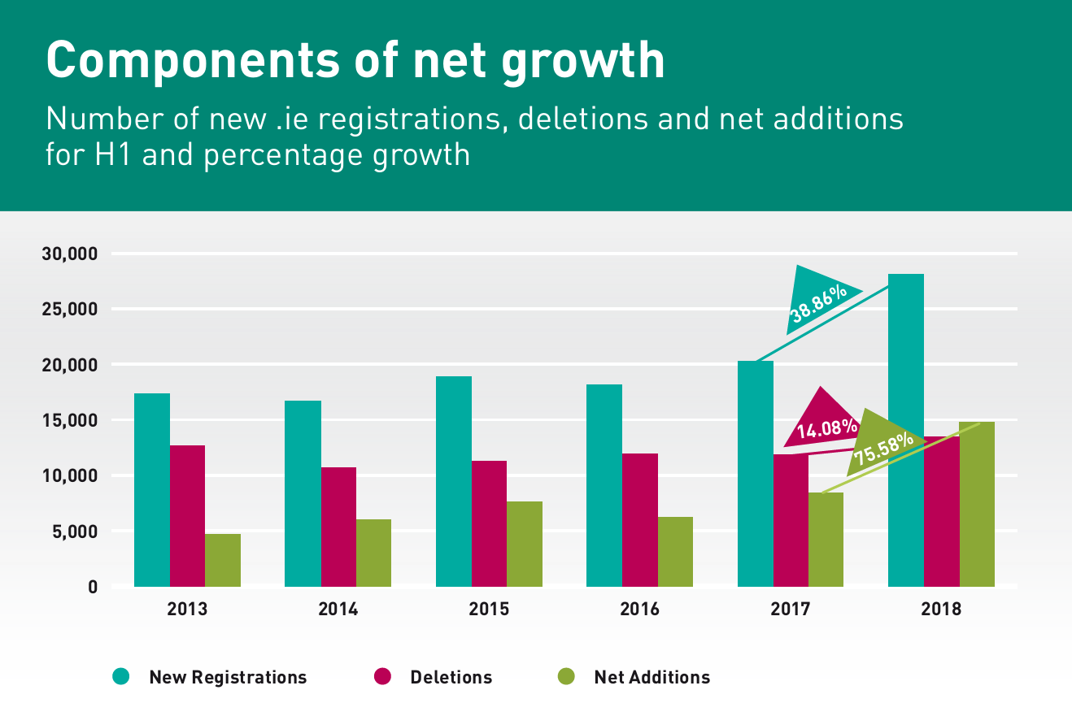
Source : .ie Domain Profile Report H1 2018

