New OPTIMISE Design Ireland Programme Brings Irish Design and Craft to a Global Online Audience
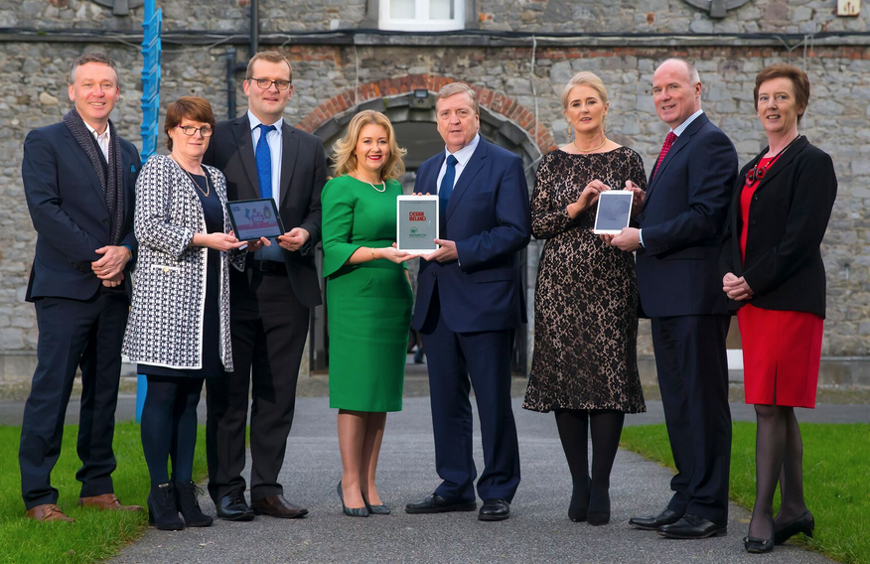Innovative inter-agency initiative announces ambitious plans to drive global e-commerce sales for 100 Irish design and craft businesses

The IE Domain Registry (IEDR), in partnership with the Design & Crafts Council of Ireland (DCCoI) and the Local Enterprise Offices (LEOs), has launched OPTIMISE Design Ireland, a new programme with bold and ambitious plans to bring Irish design and craft to the world, one business at a time. OPTIMISE Design Ireland empowers innovative, design-led Irish brands to improve their online presence, hone their digital capabilities and grow their global e-commerce sales, by bringing together best-in-class expertise across the digital, enterprise and design sectors. The 2017 and 2018 programmes will take 100 of Ireland’s brightest creative companies on a transformative digital journey, supporting them as they compete globally and grow their business within the e-commerce arena.

Welcoming the announcement, Minister for Trade, Employment, Business, EU Digital Single Market and Data Protection, Pat Breen TD said: “Design is an integral part of the innovation agenda, and it is essential that small Irish businesses can access design to ensure that their products and services can compete in international markets. I welcome this initiative which is a great example of collaboration between publicly funded bodies and which will boost the use of design by small Irish companies.”

Following a selection process for the 2017 programme, 40 businesses nationwide are participating so far. These include celebrated brands such as jewellery designer, Chupi, alongside fashion designer Alison Conneely, KaroArt ceramics, Inner Island jewellery, Jennifer Slattery Textiles, and handmade soft toy brand, Red Rufus. By the end of 2018, 100 design and craft companies will have been through the programme, which is designed to bring their business into the modern digital age, improve their competitiveness and grow their market.

Each participating business benefits from an extensive digital audit, a website health check, by an expert digital marketing agency before taking part in a series of mentoring days, with a masterclass hosted by IEDR, DCCoI and the LEOs. A follow-up meeting helps monitor their changes and improvements, as well as their progress moving forward.
The partners are bringing their unique insights and expertise to make this project effective. There are four phases to the programme and each is led by one or more of the partners:
- Selection of companies, led by DCCoI and LEOs
- Digital audit, led by IEDR
- Mentoring, led by DCCoI and LEOs
- Implementation, Trading Online Voucher Scheme led by LEOs

The IE Domain Registry (IEDR) is the owner of the OPTIMISE Fund which supports Irish business owners in planning, developing and implementing significant web enhancements and e-commerce capabilities to their existing websites.

The Design & Crafts Council of Ireland runs the DesignIreland.ie online platform to connect audiences all over the world with Ireland’s makers, their studios and their inspiration.
The Trading Online Voucher Scheme is delivered by the Local Enterprise Offices on behalf of the Department of Communications, Climate Action and Environment.
Research shows that businesses who have engaged with the Trading Online Voucher Scheme report that their sales have grown on average by 21%, and companies that are growing are employing 1.4 more people to manage their online presence. Importantly, 3 in 5 are exporting for the first time. With these impacts occurring irrespective of where a business is located, it is clear that businesses trading online generate positive impacts for economic growth and regional development.

Commenting on the OPTIMISE programme, David Curtin, Chief Executive of IEDR, said: “Buying and selling online is big business. Ireland's share of the European e-commerce marketplace is €9 billion, but today, most of that spend by Irish consumers goes abroad to foreign companies. IEDR research shows that less than a third of Irish SMEs with websites can take sales orders or process payments online. This means that small businesses up and down the country are losing out on new revenue streams and customers. This needn't be the case. Getting online, building a modern website and selling your product is more straightforward and hassle-free than it's ever been.
“This year, IEDR is proud to partner with the Design & Crafts Council of Ireland and the Local Enterprise Offices for OPTIMISE Design Ireland. The programme opens up a world of opportunities, making web design, digital skills and e-commerce more accessible to some of Ireland's most creative and innovative businesses.”

Karen Hennessy, Chief Executive of the Design & Crafts Council of Ireland, added: “We are delighted to be collaborating with IEDR and the LEOs in delivering the OPTIMISE Design Ireland programme. Working with client companies to scale and develop their digital presence and e-commerce capability is critical to growing Ireland’s design and craft sector and increasing our competitiveness in the global market place. We look forward to seeing international e-commerce sales steadily increase for leading Irish designers and makers as a result of their participation in this innovative programme.”

Fiona Deegan, Head of Enterprise, LEO Kilkenny, said: “The OPTIMISE Design Ireland programme is very well constructed. The digital audit is an impressive way to identify and target time and resources at the areas that will really make the greatest difference for each business to enhance their online presence. The OPTIMISE Programme ensures that the Trading Online Voucher is money well spent.”
Details on the OPTIMISE Design Ireland programme can be found at: https://www.iedr.ie/why-choose-ie/optimise/
- ENDS -
For further press information, please contact Elevate PR on 01 662 5652
Tara Walsh – tara@elevate.ie / Emer Igbokwe – emer@elevate.ie / Emma Kelly – emma@elevate.ie

IMAGE:
L-R: Brian McGee, Market Development Director, Design & Crafts Council of Ireland; Colette Byrne, CEO, Kilkenny County Council; Minister John Paul Phelan TD; Karen Hennessy, Chief Executive, Design & Crafts Council of Ireland; Minister for Trade, Employment, Business, EU Digital Single Market and Data Protection, Pat Breen TD; Fiona Deegan, Head of Enterprise, Local Enterprise Office Kilkenny; David Curtin, Chief Executive, IE Domain Registry; Oonagh McCutcheon, Customer Operations Manager, IE Domain Registry

NOTES FOR EDITORS
About IE Domain Registry (IEDR)
The IE Domain Registry has been managing the dot ie country code Top Level Domain (ccTLD) since 2000. Its work includes supporting and promoting the online presence of all dot ie domain names. Its vision is that the dot ie domain name will continue to be recognised globally as representing Ireland’s presence on the internet with high levels of stability, safety and resilience. The IEDR provides unique, identifiably Irish domain names along with registry and related services to the local and international internet community. Managing dot ie domains gives the IEDR valuable insight into SME performance and Ireland’s digital economy. Much of its research shows that a vast majority of companies are not fully using the internet or online sales opportunities to drive growth in their businesses. www.iedr.ie

About Design Ireland
Design Ireland is a premium brand created by the Design & Crafts Council of Ireland (DCCoI) that showcases the breadth and quality of Irish design and craft to both a global and an Irish audience. As a current and informed cultural curator, Design Ireland discovers and shares the best work created in Ireland for people who want to buy and gift authentic, quality products. Accomplished makers across Ireland are creating craft of the highest quality, and Design Ireland provides visitors to the site with ideas, inspiration and information on where to buy these beautiful, authentic Irish products. www.designireland.ie

About the Design & Crafts Council of Ireland
The Design & Crafts Council of Ireland (DCCoI) is the national agency for the commercial development of Irish designers and makers, stimulating innovation, championing design thinking and informing Government policy. DCCoI's activities are funded by the Department of Business, Enterprise and Innovation via Enterprise Ireland. DCCoI currently has 64 member organisations and over 3,200 registered clients. www.dccoi.ie
About the Local Enterprise Offices (LEOs)
The Local Enterprise Offices (LEOs) are the ‘first-stop-shop’ for providing advice and guidance, financial assistance and ‘soft’ supports in the form of training and mentoring to anyone wishing to start or grow a business. The LEOs provide a ‘signposting’ service in relation to all relevant state supports available through agencies such as Revenue, the Department of Social Protection, Education and Training Boards, the Credit Review Office and Microfinance Ireland. The LEOs can offer direct grant aid to microenterprises (10 employees or fewer) in the manufacturing and internationally traded services sector which, over time, have the potential to develop into strong export entities. Subject to certain eligibility criteria, the LEOs can provide financial assistance within three main categories, i.e. Feasibility Grants (investigating the potential of a business idea), Priming Grants (to part-fund a start-up) and Business Development Grants for existing businesses that want to expand. The LEOs also offer advice and guidance in areas such as Local Authority rates, Public Procurement and other regulations affecting business. www.localenterprise.iehttp://www.localenterprise.ie

About the Trading Online Voucher Scheme
The Trading Online Voucher Scheme is a Government grant scheme funded by the Department of Communications, Climate Action and Environment and delivered by the Local Enterprise Offices. The scheme provides training and mentoring coupled with a financial incentive of up to €2,500 (matched-funding) to micro businesses to develop their ecommerce capability. Grants are awarded on a competitive basis and eligibility requirements apply. www.dccae.gov.ie/tradingonlinevoucher

